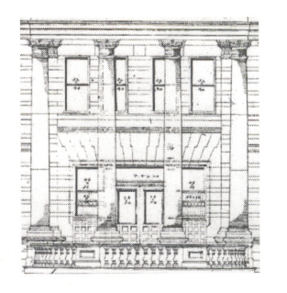
2016 Great Falls – Cascade County
Historic Preservation
Awards Nomination

Name of Person or Building you are nominating: (you may nominate yourself)
Nominee's Address:
Nominee's Phone Number:
Why should this person/building receive a historic preservation award? (Pictures would be appreciated. You may also want to submit additional materials.)
Your Name:
Your Address:
Your Phone Number:

Application Deadline: 5:00 PM on Tuesday, April 12, 2016
Submit Applications To: Great Falls – Cascade County Historic Preservation Office,
PO Box 5021, Great Falls, MT 59403.
Call 761.6955 for more information.

