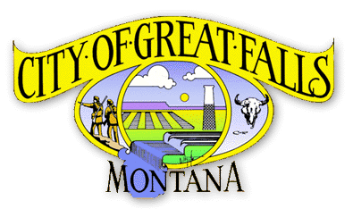PRESS RELEASE

The Park & Recreation Department provides fun family activities for the entire community

60 parks are maintained throughout the community

Over 40 miles of trail has been completed along the Missouri River

Proud home of Mansfield Theatre an intimate 1,782 state-of-the-art events venue

Generously supported by the community & the Park & Recreation Foundation

City of Great Falls
Park & Recreation Dept.
1700 River Drive North
Great Falls, Montana
406-771-1265
greatfallsmt.net/parkrec
Follow us on Facebook

FOR IMMEDIATE RELEASE
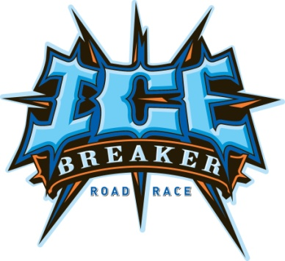

DATE: March 14, 2012

CONTACT: Patty Rearden, 406-771-1265
Deputy Director

Registration Is Now Open for the
ICE BREAKER ROAD RACE

The 33rd Annual Ice Breaker Road Race will be held Sunday, April 22, 2012. Join over 3,400 runners, joggers and fitness walkers who enter the race each year. Participants range from recreational walkers, families enjoying an outing, to serious competitive runners. The five-mile road race offers a competitive format; and the three-mile run offers both a competitive and recreational format. Pacer the Penguin will be entered in the one-mile race and will be challenging kids of all ages. Register the entire family in the one-mile jog and fitness walk and take advantage of our special family rate.

Registration is Monday-Friday, 8 a.m. to 5 p.m. at the Park and Recreation office at 1700 River Drive North. Special registration will be held at Scheels in Holiday Village Mall on April 14, 10 a.m. to 4 p.m. Registration will be held at the Civic Center Convention Center on Saturday, April 21, 10 a.m. to 6 p.m., and Sunday (Race Day) at the Convention Center, 8 a.m. to 1 p.m. A late fee of $2 per registrant will apply beginning Monday, April 16.

Register by April 10 to be included in the drawing for early registration. All participants who register during early registration will be entered into a drawing for two great prizes: a Sunkist Youth Four Wheeler donated by Pepsi, $350 value, and twenty visits to the Peak Health and Wellness Center, $300 value. The last opportunity to get in on early registration in person will be at Scheels on Saturday, April 14 or on-line Sunday, April 15. That is also the last date to register without paying the $2 per entry late fee. On-line registration is available at www.icebreakergf.com. Registration forms will also be available at Universal Athletic Stores and Scheels Stores throughout the State.

Entry fees are $12 for 10 and under, $18 for 11 and older, $50 for a family of four (family of four includes parent(s) and dependents, ages 1-18 from the same household), each additional youth in the same household is $10.

Each participant will receive a 2012 Ice Breaker long sleeved t-shirt, a unique finisher medal, and lunch after the race. The awards ceremony will begin in the Convention Center at approximately 4 p.m. for the 5-mile and 3-mile races.

A special thanks to the major sponsors including Pepsi, Benefis Health System/Orthopedic Center of Montana, Great Falls Tribune, and Walker Design Group. Without these sponsors, the race would not be possible. Pacific Steel & Recycling, Scheels, NEW, Northwestern Energy, Peak Health and Wellness Center, KRTV, Universal Athletics, Highway Specialties, City of Great Falls Public Works, Montana ExpoPark, and MAFB are also contributors to the success of the race. Troy Mellinger will be announcing on race day.

On race day, the schedule will include the following:
12:40 p.m. Stretch/aerobics to music, front steps of Civic Center
1:00 p.m. 5-mile run
1:40 p.m. Stretch/aerobics to music, front steps of Civic Center
2:00 p.m. 3-mile race
2:40 p.m. Stretch/aerobics, front steps of Civic Center
3:00 p.m. 1-mile race
4:00 p.m. Awards Ceremony
Lunch starts at 1:30 p.m.

Awards for the 5-Mile Race:
Male Female
First Place $1,500 $1,500
Second Place $ 750 $ 750
Third Place $ 500 $ 500
Masters 1st $ 200 $ 200
Masters 2nd $ 100 $ 100

Awards for the 3-Mile Race
Overall male and female winners receive a specially designed trophy and $100 cash. Overall male and female places 2 through 10 will receive special Ice Breaker awards.

Male and female age group division winners will receive a special Ice Breaker Medal.

For more information contact the Park & Recreation office at 406-771-1265 or at www.icebreakergf.com.

